**BIOLOGY ANSWER KEY**

**QUESTION BANK 1**

**Q1. Explain the following terms : 1)DFMC ,2)NST ,3)CST ,4)USG**

**A1. 1) DFMC**

The daily fetal movement count (DFMC) chart, a tool that is inexpensive, uncomplicated and non-invasive, is a clinically effective means of screening for fetal well-being after 20 weeks' gestation. The DFMC requires pregnant women to begin a fetal movement count at a selected time each day, count 10 movements and record the elapsed time from the first to the tenth movement.

**2) NST**

A nonstress test is a common prenatal test used to check on a baby's health. During a nonstress test, the baby's heart rate is monitored to see how it responds to the baby's movements. The term "nonstress" refers to the fact that nothing is done to place stress on the baby during the test.

Typically, a nonstress test is recommended when it's believed that the baby is at an increased risk of death. A nonstress test may be done after 26 to 28 weeks of pregnancy. Certain nonstress test results might indicate that you and your baby need further monitoring, testing or special care.

A nonstress test is a noninvasive test that doesn't pose any physical risks to you or your baby.

**3) CST**

A contraction stress test (CST) measures the fetal heart rate after the uterus is stimulated to contract. This is done to make sure that during labor the fetus can handle contractions and get the oxygen needed from the placenta.

This test may be recommended when a nonstress test or biophysical profile (BPP, an ultrasound done with a nonstress test) indicates a problem. It can determine whether the baby's heart rate remains stable during contractions.

In this test, the uterus is stimulated with pitocin, a synthetic form of oxytocin (a hormone secreted during childbirth). This is done with injections of pitocin or by squeezing the **mother's** nipples (causing oxytocin to be secreted). The pitocin brings on mild contractions, letting doctors see the effect of contractions while monitoring the baby's heart rate.

**4) USG (Ultrasound Sonography Test)**

An ultrasound is an imaging test that uses sound waves to create a picture (also known as a sonogram) of organs, tissues, and other structures inside the body. Unlike x-rays, ultrasounds don’t use any radiation. An ultrasound can also show parts of the body in motion, such as a heart beating or blood flowing through blood vessels.

There are two main categories of ultrasounds: pregnancy ultrasound and diagnostic ultrasound.

* Pregnancy ultrasound is used to look at an unborn baby. The test can provide information about a baby’s growth, development, and overall health.
* Diagnostic ultrasound is used to view and provide information about other internal parts of the body. These include the heart, blood vessels, liver, bladder, kidneys, and female reproductive organs.

An ultrasound can be used in different ways, depending on the type of ultrasound and which part of the body is being checked.

A pregnancy ultrasound is done to get information about the health of an unborn baby. It may be used to:

* Confirm that you are pregnant.
* Check the size and position of the unborn baby.
* Check to see you are pregnant with more than one baby.
* Estimate how long you have been pregnant. This is known as gestational age.
* Check for signs of Down syndrome, which include thickening in the back of the baby's neck.
* Check for birth defects in the brain, spinal cord, heart, or other parts of the body.
* Check the amount of amniotic fluid. Amniotic fluid is a clear liquid that surrounds an unborn baby during pregnancy. It protects the baby from outside injury and cold. It also helps promote lung development and bone growth.

**Q2. DISCUSS THE WORKING PRINCIPLE AND SIGNIFICANCE OF PULSE OXIMETER.**

## A2. Pulse oximetry is a simple, relatively cheap and non-invasive technique to monitor oxygenation. It monitors the percentage of haemoglobin that is oxygen-saturated. Oxygen saturation should always be above 95%, although in those with long-standing respiratory disease or cyanotic congenital heart disease, it may be lower, corresponding to disease severity

## Principles of pulse oximetry

Oximeters work by the principles of spectrophotometry: the relative absorption of red (absorbed by deoxygenated blood) and infrared (absorbed by oxygenated blood) light of the systolic component of the absorption waveform correlates to arterial blood oxygen saturations. Measurements of relative light absorption are made multiple times every second and these are processed by the machine to give a new reading every 0.5-1 second that averages out the readings over the last three seconds.

Two light-emitting diodes, red and infrared, are positioned so that they are opposite their respective detectors through 5-10 mm of tissue. Probes are usually positioned on the fingertip, although earlobes and forehead are sometimes used as alternatives.

**IMPORTANCE OF PULSE OXIMETER**

Pulse oximetry may be used to see if there is enough oxygen in the blood. This information is needed in many kinds of situations. It may be used:

* During or after surgery or procedures that use sedation
* To see how well lung medicines are working
* To check a person’s ability to handle increased activity levels
* To see if a ventilator is needed to help with breathing, or to see how well it’s working
* To check a person has moments when breathing stops during sleep (sleep apnea)

Pulse oximetry is also used to check the health of a person with any condition that affects blood oxygen levels, such as:

* Heart attack
* Heart failure
* Chronic obstructive pulmonary disease (COPD)
* Anemia
* Lung cancer
* Asthma
* Pneumonia

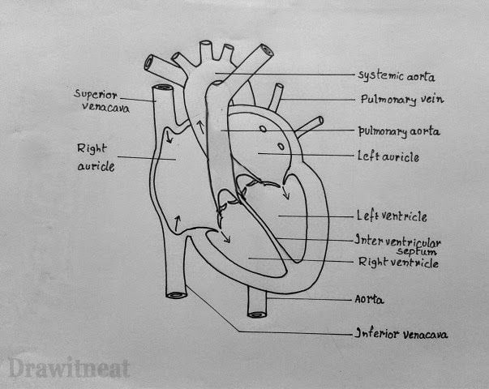**Q3. DRAW THE STRUCTURE OF HEART**

**Q4. LIST ELECTRODES USED FOR 1)ECG , 2)EMG**

**1) ECG**

An electrocardiogram is a **simple, painless test that measures your heart's electrical activity**.

* Full-surface Gel Monitoring Electrodes (for children, for adults)
* X-ray Permeable Monitoring Electrodes (large size, small size, with adhesive frames)
* Monitoring Electrodes with Adhesive Frames (foam type, cross type, various shapes)
* Electrodes for Examinations (Resting ECG Electrodes)

**2) EMG**

The bioelectrical activity inside the muscle of a human body is detected with the help of EMG electrodes. There are two main types of EMG electrodes: surface (or skin electrodes) and inserted electrodes. Inserted electrodes have further two types: needle and fine wire electrodes.

* SURFACE (OR SKIN ELECTRODES)
  + Gelled EMG Electrodes
  + Dry EMG electrodes
* INSERTED ELECTRODES
  + NEEDLE ELECTRODES
  + FINE WIRE ELECTRODES

**Q5. WHICH BODY PART ARE DETECTED BY;-**

ECG__**cardiac (heart)** ____.

EMG____ **muscle**.____.

EOG____**eye**______.

EEG_____**Brain** _______.

OXIMETER___**Finger**_____.

**Q6. WHAT DO YOU MEAN MY SYNAPSE? LIST THE THREE TYPE OF SYNAPSE IN THE BODY.**

synapse, also called neuronal junction, the site of transmission of electric [nerve](https://www.britannica.com/science/nerve-anatomy) impulses between two nerve cells (neurons) or between a neuron and a gland or muscle cell (effector). A synaptic connection between a [neuron](https://www.britannica.com/science/neuron) and a muscle cell is called a [neuromuscular junction](https://www.britannica.com/science/neuromuscular-junction).

**Axodendritic synapse**

**Axosomatic synapse**

**Axoaxonic synapses**

There are two types of synapses found in your body: electrical and chemical. Electrical synapses allow the direct passage of ions and signaling molecules from cell to cell. In contrast, chemical synapses do not pass the signal directly from the presynaptic cell to the postsynaptic cell. In a chemical synapse, an action potential in the presynaptic neuron leads to the release of a chemical messenger called a neurotransmitter. The neurotransmitter then diffuses across the synapse and binds to receptors on the postsynaptic cell. Binding of the neurotransmitter leads to the production of an electrical signal in the postsynaptic cell.

**Q7. Discuss the role of IPSP and EPSP in post synaptic transmission of action potential.**

**A1. IPSP**

An inhibitory postsynaptic potential (IPSP) is a kind of synaptic potential that makes a postsynaptic neuron less likely to generate an action potential.

An IPSP is received when an inhibitory presynaptic cell, connected to the dendrite, fires an action potential. The IPSP signal is propagated down the dendrite and is summed with other inputs at the axon hilllock. The IPSP decreases the neurons membrane potential and makes more unlikely for an action potential to occur.

An IPSP is an electric charge on the postsynaptic membrane which is caused building of inhibitory neurotransmitters and make they postsynaptic membrane less likely to generate an action potential.

**EPSP**

In neuroscience, an excitatory postsynaptic potential (EPSP) is a postsynaptic potential that makes the postsynaptic neuron more likely to fire an action potential.

The EPSP signal is propagated down the dendrite and is summed with other inputs at the axon hilllock. The EPSP increases the neurons membrane potential. When the membrane potential reaches threshold the cell will produce an action potential and send the information down the axon to communicate with postsynaptic cells.

An EPSP is an electric charge of the post synaptic membrane which is called by the building of excitory neurotransmitter and makes the post synaptic membrane to generate an action potential.

**Q8. Discuss the process of generation and propagation of action potential across neuronal membrane.**

An **action potential** occurs when a neuron sends information down an axon, away from the cell body. Neuroscientists use other words, such as a "spike" or an "impulse" for the action potential. The action potential is an explosion of electrical activity that is created by a **depolarizing current**.

Action potentials are caused when different ions cross the neuron membrane. A stimulus first causes sodium channels to open. Because there are many more sodium ions on the outside, and the inside of the neuron is negative relative to the outside, sodium ions rush into the neuron. Remember, sodium has a positive charge, so the neuron becomes more positive and becomes depolarized. It takes longer for potassium channels to open. When they do open, potassium rushes out of the cell, reversing the depolarization. Also at about this time, sodium channels start to close. This causes the action potential to go back toward -70 mV (a repolarization). The action potential actually goes past -70 mV (a hyperpolarization) because the potassium channels stay open a bit too long. Gradually, the ion concentrations go back to resting levels and the cell returns to -70 mV.

And there you have it...the **Action Potential.**

Action potentials are propagated along the axons of neurones via **local currents**. Local currents induce depolarisation of the adjacent axonal membrane and where this reaches a threshold, further action potentials are generated. The areas of the membrane that have recently depolarised will not depolarise again due to the refractory period – meaning that the **action potential will only travel in one direction.**

These local currents would eventually decrease in charge until a threshold is no longer reached. The distance that this would take depends on the membrane capacitance and resistance:

* **Membrane capacitance** – the ability to store charge. The lower capacitance results in a greater distance before the threshold is no longer reached.
* **Membrane resistance** – depends on the number of ion channels open. The lower the number of channels open, the greater membrane resistance is. A higher membrane resistance results in a greater distance before the threshold is no longer reached.

**Q9. Explain diagrammatically the process of synaptic transfer from presynaptic membrane to postsynaptic membrane.**

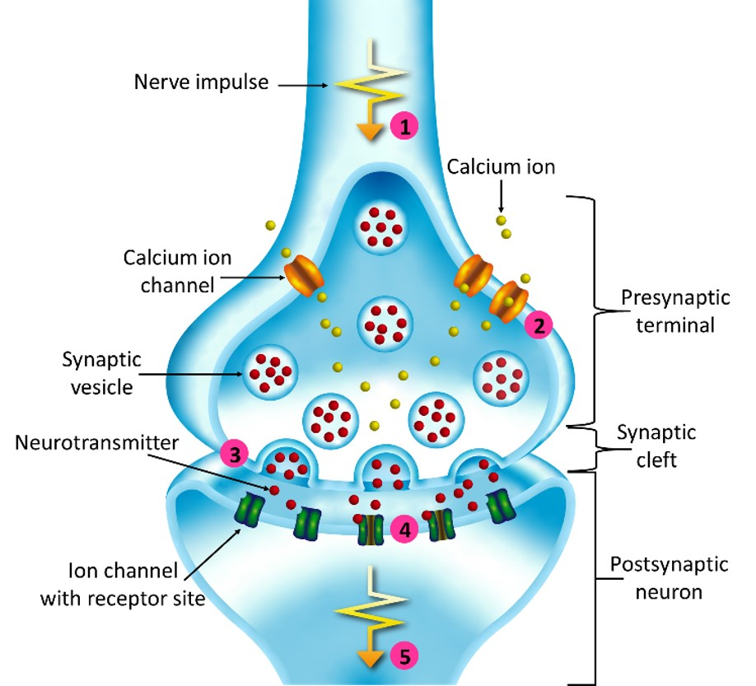

(1) A nerve impulse arrives. (2) This causes calcium ion channels to open, resulting in an influx of calcium ions in the terminal. (3) This causes synaptic vesicles to fuse with the terminal membrane, releasing neurotransmitter into the gap between neurons, known as the synaptic cleft. (4) The neurotransmitters bind to receptor sites on ion channels in the postsynaptic membrane, causing them to open. (5) Ions flow into the postsynaptic neuron, which generates an action potential when a threshold level is reached.

**Q10. What are bioelectrodes? List properties and application of bioelectrode.**

**A10. Bioelectrodes are devices used to produce or measure electrical activity in the body for electrophysiological stimulation or monitoring.Stimulation of electrically excitable tissue is achieved by establishing electrical fields in the tissue, using electrodes. These electrodes transduce electrons (the charge carrier for the electrical circuitry used in therapeutic stimulation devices) to ions (the charge carrier in the body), allowing electric charge to be injected into tissue. The materials used for these electrodes are integral to ensuring that this charge injection occurs safely and effectively.**

**Key Properties of Bioelectrodes**

Bioelectrodes should possess the following properties:

* They should be good conductors
* They should have low impedance
* They should not polarize when a current flows through them
* They should establish a good contact with the body and not cause motion
* Potentials generated at the metal electrolyte (jelly) surface should be low.
* They should not cause itching, swelling or discomfort to the patient for example the metal should not be toxic
* They should be mechanically rugged
* They should be chemically inert
* They should be easy clean

**Biomedical electrodes are used in various forms in a wide range of biomedical applications, including:**

**1. The detection of bioelectric events such as the electrocardiogram (ECG).**

**2. The application of therapeutic impulses to the body**

**[e.g., cardiac pacing and defibrillation and transcutaneous electrical nerve stimulation (TENS)].**

**3. The application of electrical potentials in order to**

**facilitate the transdermal delivery of ionized molecules for local and systemic therapeutic effect (iontophoresis).**

**4. The alternating current (ac) impedance characterization of body tissues**

**Q11.Discuss about the different types of electrodes used for 1)ECG,2)EEG,3)EMG.**

Electrodes are defined as a solid electric conductor through which an electric current enters or leaves an electrolytic cell. It converts ionic potentials to electronic potentials. Different types of electrodes used for biological measurements depend on the anatomical locations, from where the bioelectric signals are measured. Bioelectric electrodes acquire signals like ECG, EEG, EMG, etc.

There are three main types of electrodes:

* Microelectrodes
* Needle electrodes
* Body Surface electrodes

**Microelectrodes**

Microelectrode measures the electric potential from within a single cell. It has very small diameter tips that can penetrate deep into the cell without damaging the human cell. The functions of microelectrodes are potential recording to inject medicines. Generally,when microelectrode is inside cell, reference electrode is outside the cell. It has high impedances in range of mega ohm due to their small size. Two types of microelectrode are

* Metal Microelectrode
* Non- Metallic (Micropipette)

**Depth Electrodes**

Depth electrode studies the electrical activity of the neurons in the surface of the brain. This type of electrode consists of bundle of Teflon insulated platinum and iridium alloy wires.

For easy insertion of the electrodes into the brain, the end of the supporting wire is round-shaped. The number of individual electrodes forms the electrode array or bundle. In the bundle of electrodes, the end of each individual wires has the individual electrode.

**Needle Electrodes**

**Needle electrode** records the peripheral nerve action potential. It resembles a medicinal syringe. At one end a short insulated wire is bent. The bent portion passes through the lumen of the needle. This setup goes into the muscle. Now the needle is withdrawn. The bent wire remains inside the muscle. Two type of needle electrodes namely

Mono-polar Electrode: This type uses single reference electrode placed on the skin.

Bi – polar Electrode: This type has one reference electrode and one active electrode.

**Body Surface electrodes**

Surface electrodes are those which are placed in contact with the skin of the subject in order to obtain bioelectric potentials from the surface.

Body surface electrodes are of many sizes and types. In spite of the type, any surface electrode can be used to sense ECG, EEG, EMG etc.

Types of body surface electrodes.

1. Immersion electrodes 2. Plate electrodes 3. Floating electrodes 4. Disposable electrodes

5. Suction electrodes 6. Ear clip & Scalp electrodes

**Q12. SAME AS Q2**

**Q13. SAME AS Q1.**

**Q14. NAME THE TYPE OF SYNAPES FORMED BETWEEN AXON AND DENDRITE.**

**A14. Axodendritic synapse**

The most common type of synapse is an axodendritic synapse, where the axon of the presynaptic neuron synapses with a dendrite of the postsynaptic neuron.

**Q15. List the values of membrane potential during: 1) Resting membrane potential, 2) Action potential, 3) threshold membrane potential**

**A15.**

* 1. **Resting membrane potential** The resting membrane potential of a neuron is about -70 mV (mV=millivolt) - this means that the inside of the neuron is 70 mV less than the outside. At rest, there are relatively more sodium ions outside the neuron and more potassium ions inside that neuron.
  2. **Action potential**

Although the membrane potential changes about 100 mV during an action potential, the concentrations of ions inside and outside the cell do not change significantly. They remain close to their respective concentrations when then membrane is at resting potential

* 1. **Threshold membrane potential**

Most often, the threshold potential is a membrane potential value between –50 and –55 mV, but can vary based upon several factors. A neuron's resting membrane potential (–70 mV) can be altered to either increase or decrease likelihood of reaching threshold via sodium and potassium ions.

**Q16. SAME AS Q7**

**Q.17 What are surface electrodes?**

**Body Surface electrodes**

Surface electrodes are those which are placed in contact with the skin of the subject in order to obtain bioelectric potentials from the surface.

Body surface electrodes are of many sizes and types. In spite of the type, any surface electrode can be used to sense ECG, EEG, EMG etc.

Types of body surface electrodes.

1. Immersion electrodes 2. Plate electrodes 3. Floating electrodes 4. Disposable electrodes

5. Suction electrodes 6. Ear clip & Scalp electrodes